English Exam N°1
Level: 1AM
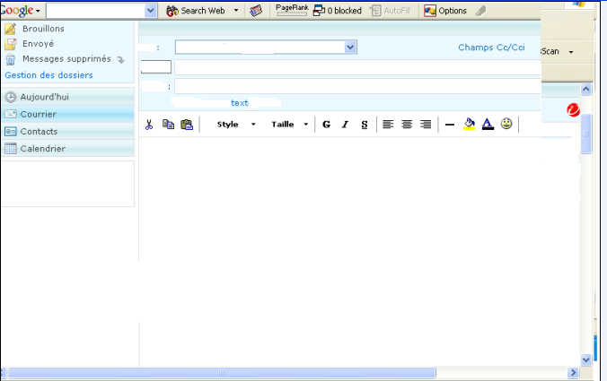
Text
From: ryadboy@hotmail.com
To: sallygirl@yahoo.fr

Hello Sally, I am Ryad, I am from Algeria. I am 13.
Where are you from Sally?

Part One: A/ Reading Comprehension (6pts)
Activity One: Choose the correct answer.
- The text is : a) a letter b) an e-mail c) a newspaper

- The sender is : a) Ryad b) Steve c) Aminata

Activity Two: Say “true” or “false”
- Ryad is English (...........................)
- Ryad is 13 (......................)

B/ Mastery of language : (8pts)
Activity One: Write the numbers in full .
O1→ .............................. 02 → ......................... 03 → ............................. 10→ .............................
12 → .............................. 20 → ..........................
Activity Two: Classify these words according to their sounds :
/en/ | /een/
“thirteen - listen – sixteen – Sweden “

Activity Three : Complete the missing words :
- Ryad is from ..................................so , Ryad is Algerian .
- Sally is from England , so Sally is .............................
Activity Four : Re-order according to the alphabetical order.
table - desk - book - chair
Part Two: Integrated Situation (6pts)
- Ryad invites Sally to visit Algeria .
- When Sally comes to Algeria she meets her Algerian friends and she introduces herself to them
- Re-order the words to make a correct speech .

Sally: / am/ I / Hello / Sally . / →
Friends : / where / you/ Sally / Hello/ are / from / ? / →
Sally : /./ am / I / English / →
Friends : to meet / you / . / Nice / Sally / →
Sally : you / Glad to / . / meet / →
Good Luck

